Orientation to Self-Grading of Discussions at
http://www.screencast-o-matic.com/watch/cojYcXfB1F

Script
By Dr. Nancyruth Leibold

Slide 1
Greetings! Welcome to Orientation of Self Grading of Discussions. My name is Dr. Nancyruth Leibold and I teach in the Department of Nursing, along with my wonderful colleagues, Dr. Laurie Johansen, and Dr. Ruth VanHeukelom.
Slide 2
In self-grading of discussions, learners grade their own discussions. A grading rubric is used with the required criteria. The rubric is converted into a quiz format with five questions that include response descriptions. Learners select the description that best matches their performance in the discussion.
Slide 3
In this short video, I will explain how to complete self-grading of discussions.
Slide 4
The basis for self-grading of discussions is Adult Learning Theory, Self-Assessment and Self-Reflection. Adults are self-directed learners (Candela, 2012) and prefer control over their own learning (Knowles,1984).

Reflection is a concept that is a necessary aspect of improving one’s work. For nurses, this is a valuable skill for continuous quality improvement. The encouragement of nurses to review/reflect upon their performance and take note of areas done well and areas for improvement is incorporated into self-grading of discussions.

Now that you have an introduction to the theory behind self-grading of online discussions, we will turn our focus to how you will do this in the course!
Slide 5
Online Discussion Evaluation Rubric
Your syllabus or courseroom includes the Online Discussion Evaluation Rubric. It is important to read the information in this rubric and use it to guide your discussions.
Initial discussion posts are due by 11:59 pm on Thursday and a response to at least two other people is due by 11:59 pm on Sunday. Any discussion posts after the 11:59 pm deadline on Sunday will be given zero credit. It is expected that students actively participate in the discussion forums. Each student is expected to read all weekly discussion posts, contribute one initial response discussion post weekly, and contribute participation discussion responses to at least two other students’ posts.
Each initial discussion posting should end with a question related to the topic to stimulate further discussion.
Slide 6
The initial posting must include at least two APA citations and references.
The participation postings to peers must be substantial and may include a story about a related experience, a probing question, or point(s) with citations and references from the literature.

Slide 7
Students self-grade their posts the following week by Thursday at 11:59 pm under the Quiz section in the D2L Brightspace courseroom. So, for example, week one discussions are self-graded during week 2 by Thursday, 11:59 pm. The faculty member will review the self-grades for accuracy and reserves the right to adjust any grades.

Slide 8
Be sure to review the grading rubric for discussions.
Rating Points | Mechanics of Posting
1 | Complete sentences, well organized, grammatically correct and free of spelling errors (have used spell check to help ensure this)
.75 | Complete sentences, well organized, but some (2 or less per paragraph) grammar and/or spelling errors
.5 | Complete sentences, comprehensible, organization could be improved to present a more coherent argument or statement, has three or more grammar and/or spelling errors per paragraph
0 | Poor sentence structure inadequate organization, several grammar and/or spelling errors; run-on sentences
Rating Points | Participation in Discussion
1 | Makes postings on at least two different days (Thursday initial post due by 11:59PM, Sun response to two other people due by 11:59PM). Responds to at least 2 peers’ postings
.75 | Late first post and/or posts everything 1 day only. Responds to at least 2 peers’ postings
.5 | Responds to only 1 peer’s posting
0 | Does not reply to or provides minimal comments and information to other participants
Rating Points | Content of Initial Posting
1 | Initial response thoroughly addresses all parts of the discussion, is clearly and concisely stated, and demonstrates that the content was appropriately reviewed, understood, and synthesized. Posts by 11:59PM Thursday
.75 | Initial response addresses most, but not all, of the discussion. Comments are reasonably organized and demonstrate adequate familiarity and analysis of the content and posts by 11:59PM Thursday
.5 | Initial response Shows limited knowledge and evaluation of the topic or limited to information that could be derived from prior posts and/or late initial post
0 | Message was unrelated to discussion
Rating Points | Critical Thinking Evidenced by Posting
1 | Offered a critical analysis of an existing posted idea or introduced a different interpretation to an existing idea
.75 | Agreed or disagreed with existing discussion and provided limited justification/explanation
.5 | Agreed or disagreed with existing discussion but provided no justification/explanation or support
0 | Provided no evidence of agreement or disagreement with existing discussion
Rating Points | APA Format
1 | Provides evidence-based, scholarly resources to support one’s position on the posed topic or idea; References are correctly & accurately presented in APA Format— in-text referencing within the posting
.75 | Provides evidence-based, scholarly resources, but uses incorrect APA Format for in-text referencing
.5 | Provides evidence-based, scholarly references and incorrect APA Format OR provides non-scholarly references with correct APA Format in-text
0 | Provides no scholarly reference to support position/ideas in postings/discussion AND/OR uses no APA Format
Rubric authored by Laura M. Schwarz ©, adapted by Nancyruth Leibold and Laurie Johansen

Slide 9

Initial postings should include in-text citations and references. One may be a textbook or other professional source. At least one should be a journal article.

Slide 10

Participation postings to a peer may include one of the following:
An experience related to the discussion
Something from the Literature with Citation/references
A provocative question

Slide 11

In the courseroom, go to the assessment menu, and then select quizzes on the dropdown menu.
Then select the quiz for the matching discussion. It will have 5 questions in multiple choice format and you will select the answer response that best matches your performance for the discussion.

Submit the quiz at the end and it records the score in your grades.

It isn’t really a quiz but is set up in D2L Brightspace this way so you can have control of your own grading.

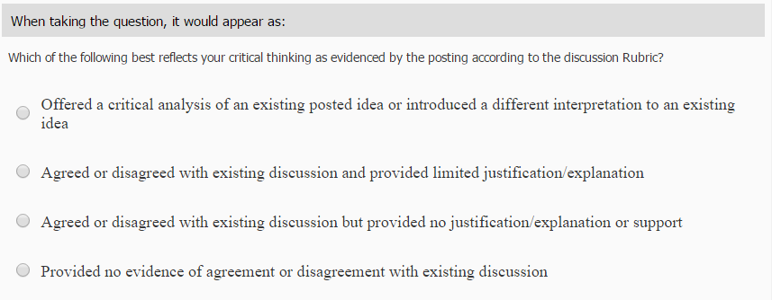

Slide 12

Summary

In this video, the how to of discussion self grading was reviewed. If you have any questions, please contact your instructor.

Slide 13
References

Candella, (2012). Chapter 13: From Teaching to Learning. In D. M. Billings & J. A. Halstead (Eds.), Teaching in nursing: A guide for faculty (4th ed, pp. 212). St. Louis, MO: Elsevier
Knowles, M. S. (1984). Andragogy in action. San Francisco: Jossey-Bass.

